What is data analytics?

Data analytics converts raw data into actionable insights. It includes a range of tools, technologies, and processes used to find trends and solve problems by using data. Data analytics can shape business processes, improve decision-making, and foster business growth.

## Why is data analytics important?

Data analytics helps companies gain more visibility and a deeper understanding of their processes and services. It gives them detailed insights into the customer experience and customer problems. By shifting the paradigm beyond data to connect insights with action, companies can create personalized customer experiences, build related digital products, optimize operations, and increase employee productivity

# Why Every Data Scientist Should Know NumPy

Discover the power of Python's NumPy library in the dynamic field of data science. With diverse applications in numerical computing, array manipulation, data analysis, and machine learning, NumPy is a critical tool for data scientists across various industries.

.

# Machine Learning: The First Step is to Understand Simple Linear Regression

Linear regression is the most fundamental and widely applied concept in daily life.

Simple linear regression is used to find the correlation between two variables (explanatory and response variables).

In addition, linear regression aims to predict the value of the response variable from the value of the explanatory variable that has never been observed before

# Get an intuition of simple linear regression

Linear regression works by **drawing a line that is as close as possible to the existing data points** [2]. The data points are the values of the explanatory and response variables. Simple linear regression **assumes that the two explanatory and response variables are linearly correlated** so that a straight line can be drawn.

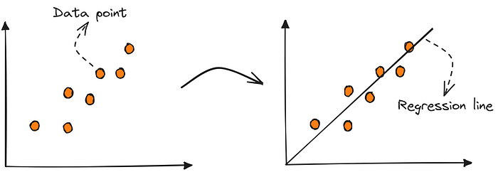

# Rapid Prototyping: Developing GUI Applications with Python and Tkinter

Rapid prototyping has emerged as a key methodology, allowing developers to quickly create functional prototypes that demonstrate the core features of an application. When it comes to developing graphical user interface (GUI) applications, Python coupled with Tkinter offers a powerful combination for rapid prototyping. Let’s evaluate the combination.

### The Need for Rapid Prototyping

In the dynamic landscape of technology, the ability to swiftly prototype and iterate upon software ideas is crucial. Rapid prototyping enables developers to gather valuable feedback early in the development cycle, leading to faster iterations and ultimately, better products. GUI applications require careful consideration of user interface design and functionality. Python, with its simplicity and versatility, paired with Tkinter, a standard GUI toolkit for Python, provides developers with the tools needed to rapidly prototype GUI applications.

### Python and Tkinter: A Dynamic Duo for Rapid Prototyping

Python’s popularity among developers stems from its readability, ease of use, and vast ecosystem of libraries and frameworks. Tkinter, being included with most Python installations, offers a convenient solution for creating GUI applications without the need for additional installations or dependencies. Together, Python and Tkinter empower developers to quickly bring their ideas to life, iterating upon them based on user feedback and requirements.

### Benefits of Python and Tkinter:

#### 1. Streamlined Development Process

One of the primary advantages of using Python and Tkinter for rapid prototyping is the streamlined development process. Python’s syntax is clean and concise, allowing developers to write code quickly and focus on the logic of their applications rather than getting bogged down by complex syntax. Tkinter provides a set of pre-built widgets and tools for creating GUI elements, further expediting the development process. This combination enables developers to iterate rapidly, making changes and improvements to their prototypes with minimal effort.

#### 2. Flexibility and Customization

Despite its simplicity, Python offers a high degree of flexibility and customization. Developers can leverage Python’s extensive library of modules to extend the functionality of their applications as needed. Tkinter, likewise, allows for the creation of custom widgets and layouts, enabling developers to tailor the user interface to suit the specific requirements of their project. This flexibility is invaluable during the prototyping phase, as it allows developers to experiment with different design concepts and features quickly.

#### 3. Cross-Platform Compatibility

In today’s multi-platform world, cross-platform compatibility is essential for reaching a broad audience. Python’s cross-platform nature, combined with Tkinter’s ability to create native-looking interfaces, ensures that GUI applications developed with these tools will run seamlessly on various operating systems, including Windows, macOS, and Linux. This compatibility eliminates the need to develop separate versions of the application for different platforms, further speeding up the prototyping process.

### Conclusion: Hire Expert Python Developers for Rapid Prototyping

Rapid prototyping with Python and Tkinter offers a fast and efficient way to develop GUI applications that meet the evolving needs of businesses and users alike. By leveraging Python’s simplicity, flexibility, and cross-platform compatibility, along with Tkinter’s rich set of tools for creating graphical interfaces, developers can quickly iterate upon their ideas and bring them to market faster than ever before. For businesses looking to stay ahead of the competition, [Hiring Expert Python Developers](https://pitangent.com/hire-expert/python-developer/) is essential. Their expertise and proficiency in Python and Tkinter will ensure that your rapid prototyping efforts are successful, leading to the creation of innovative and user-friendly GUI applications that drive business growth.

### FAQs:

**FAQ 1. Why choose Python and Tkinter for rapid prototyping of GUI applications?**

Python, known for its simplicity and vast ecosystem, coupled with Tkinter, a standard GUI toolkit for Python, provides a powerful combination for rapid prototyping. Python’s readability and ease of use, along with Tkinter’s inclusion with most Python installations, make them convenient choices for swiftly bringing GUI application ideas to life without the hassle of additional installations or dependencies.

**FAQ 2: How do Python and Tkinter streamline the development process for prototyping?**

Python’s clean and concise syntax allows developers to focus on the logic of their applications rather than getting tangled in complex syntax. Tkinter offers pre-built widgets and tools for creating GUI elements, further expediting development. Together, they facilitate rapid iteration, enabling developers to make changes and improvements to prototypes with minimal effort, speeding up the entire development cycle.

**FAQ 3: Can Python and Tkinter accommodate customization and flexibility during prototyping?**

Absolutely. Python’s extensive library of modules and Tkinter’s support for custom widgets and layouts allow for a high degree of flexibility and customization. Developers can experiment with various design concepts and features quickly, tailoring the user interface to meet specific project requirements during the prototyping phase.

**FAQ 4: Are GUI applications developed with Python and Tkinter compatible across different platforms?**

Yes. Python’s cross-platform nature combined with Tkinter’s ability to create native-looking interfaces ensures seamless execution on various operating systems including Windows, macOS, and Linux. This compatibility eliminates the need for separate platform-specific development, further accelerating the prototyping process.

**FAQ 5: Why is hiring expert Python developers crucial for successful rapid prototyping?**

Expert Python developers bring proficiency and expertise to the table, ensuring that rapid prototyping efforts are not only successful but also efficient. Their deep understanding of Python and Tkinter allows for optimized utilization of these tools, leading to the creation of innovative and user-friendly GUI applications that drive business growth.

# Machine Learning: The First Step is to Understand Simple Linear Regression

In the machine learning universe, who doesn’t know about linear regression? Of course, everyone knows about it. Linear regression is the most fundamental and widely applied concept in daily life. Simple linear regression is used to find the correlation between two variables (explanatory and response variables). In addition, linear regression aims to predict the value of the response variable from the value of the explanatory variable that has never been observed before [1].

I will explain simple linear regression using a little math in this article. The goal is that you can understand how it works and how to apply it using Python.

# Get an intuition of simple linear regression

Linear regression works by **drawing a line that is as close as possible to the existing data points** [2]. The data points are the values of the explanatory and response variables. Simple linear regression **assumes that the two explanatory and response variables are linearly correlated** so that a straight line can be drawn.



Illustration of a linear regression model that draws a straight line between data points (Image by author)

How do we get the regression line? **1)**The first step is to randomly select a straight line. **2)** Next, randomly select data points and adjust the line as close as possible to each data point. **3)** Repeat the second step several times until you get a line that is as close as possible to all data points [2].

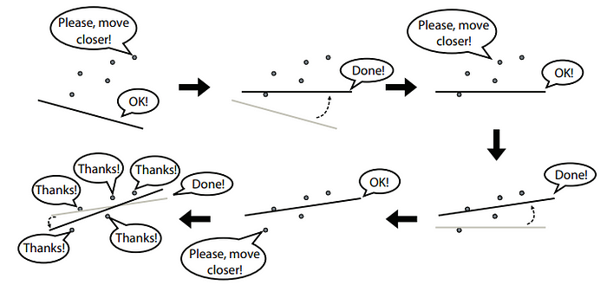

Illustration of a linear regression algorithm to determine the best line that is as close as possible to all data points [2]

Let’s imagine we have a collection of student data containing the study duration and the score obtained during the exam. We are asked to predict the students’ scores from their study duration. Let’s try to apply simple linear regression thinking to this problem.

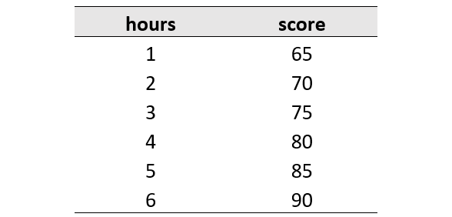

Student score dataset

Based on the information from the data, what is the score if a student studies for 7 hours? The answer is 95. You may realize that t**he longer the study duration, the better score they will get**. From the pattern of the data, we can conclude that for every 1 hour of study duration, they get a score of +5. We can think that the score is obtained from a combination of two things: the score obtained by students with <1 hour of study duration and the score obtained by students while studying. Let’s simplify it using a formula:

https://miro.medium.com/v2/resize:fit:541/1*222vjO_2WxfHMFl0bzjuVQ.png

What we have here is a formula to predict the score that students get from their study duration. Using the formula, we can predict that a student who studies for 7 hours will most likely get a score of 95.

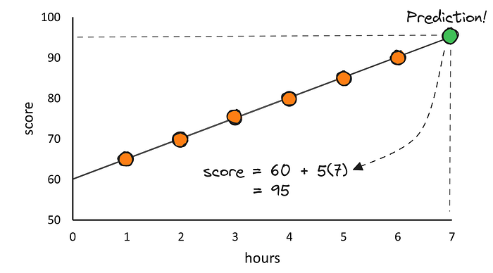

Illustration of predicting students’ scores from their study duration using the concept of simple linear regression (Image by author)

The formula we get is the same as the formula in simple linear regression. In simple linear regression, the formula is like this:

https://miro.medium.com/v2/resize:fit:279/1*DjAiIDd-BR3lZLMiloCmNw.png

Yes, the simple linear regression formula has actually been learned in middle school. Back then, we probably only used it to find the gradient of a straight line. In simple linear regression, the formula means the following:

* **y** → the response/target variable that we are trying to predict from the explanatory variables. In the above problem, this is the “score”.
* **x** → the explanatory variable we are using to make a prediction. In the problem above, this is “hours”.
* **m** → Slope is the steepness of the regression line that tells us how much we expect the y value to increase when we increase the x value by one unit. In machine learning, the slope is also known as **weight**.
* **c** → The intercept tells us where the regression line crosses the vertical y-axis. In machine learning, the intercept is also known as **bias**.

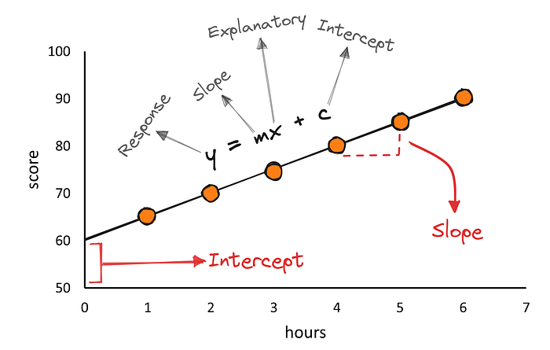

Simple linear regression anatomy (Image by author)

Next, how do we know how well our regression line fits the data points? The answer is to **minimize the error in the model prediction to find the best line**. Defining and measuring the error of a model is called **loss function** or **cost function** sometimes also called **error function**. The difference between the predicted value and the observed value is called the **residual (error)**. The measure of the fit of a model to predict all values of the response variable close to the observed values is called the **residual sum of squares (RSS/SSres)** [1].

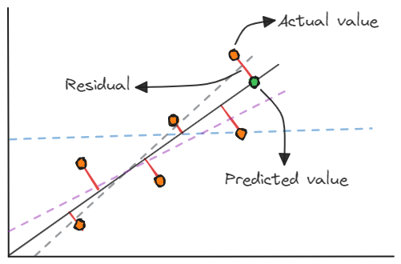

Residual vs. actual value vs. predicted value in simple linear regression (Image by author)

# Perform simple linear regression using Python

After getting an intuition about the concept of simple linear regression, we will proceed by performing simple linear regression using Python. You can download the dataset that we will use on [Kaggle](https://www.kaggle.com/datasets/shubham47/students-score-dataset-linear-regression" \t "_blank). There are some libraries that we need to import first that can make it easier for us when building a simple regression model.

import numpy as np  
import pandas as pd  
import matplotlib.pyplot as plt

Next, we can read and load the dataset using Pandas.

# read and load the data  
df = pd.read\_csv("score.csv")  
df.head()

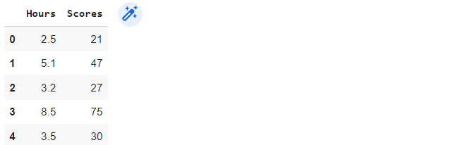

Output

# get information about the data  
df.info()  
  
# output  
<class 'pandas.core.frame.DataFrame'>  
RangeIndex: 25 entries, 0 to 24  
Data columns (total 2 columns):  
 # Column Non-Null Count Dtype   
--- ------ -------------- -----   
 0 Hours 25 non-null float64  
 1 Scores 25 non-null int64   
dtypes: float64(1), int64(1)  
memory usage: 528.0 bytes

# data preparation  
from sklearn.model\_selection import train\_test\_split  
  
X = df.iloc[:,:-1].values  
y = df.iloc[:, 1:].values  
X\_train, X\_test, y\_train, y\_test = train\_test\_split(X,   
 y,   
 test\_size=0.3,  
 random\_state=99)

The data set has two columns, “Hours” and “Scores”. The “Hours” column will be the explanatory variable, while the “Scores” column will be the response variable. In addition, the dataset only consists of 25 rows and no missing values. We also need to separate the data set into training and test data. The training data is used to build a simple regression model, while the test data is used to evaluate how good our model is. Now is the time to build the regression model!

# build regression model  
from sklearn.linear\_model import LinearRegression  
  
model\_reg = LinearRegression()  
model\_reg.fit(X\_train, y\_train)

To build and train a simple regression model, we can use Scikit-learn. To see the fit of the regression model to the data set, we can visualize it using Matplotlib.

# visualize the regression model  
X\_vis = np.array([0, 10]).reshape(-1, 1)  
y\_vis = model\_reg.predict(X\_vis)  
plt.scatter(X\_train, y\_train, label="Actual values")  
plt.plot(X\_vis, y\_vis, "-r", label="Regression line")  
plt.title("Regression analysis")  
plt.ylabel("Score")  
plt.xlabel("Hours")  
plt.xlim(0, 10)  
plt.ylim(0, 100)  
plt.legend()

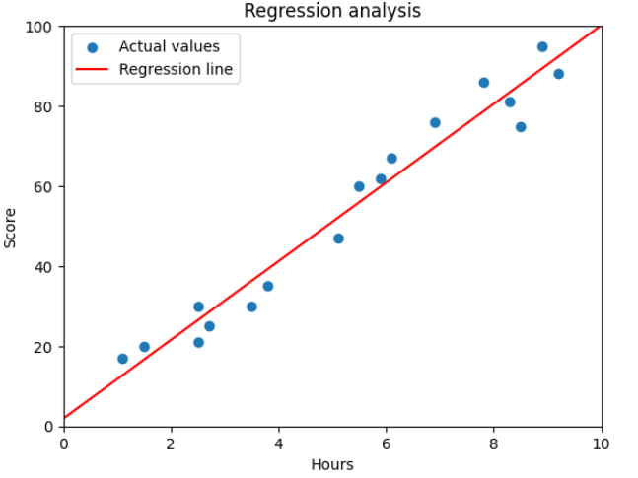

Simple linear regression model (Output)

The simple regression model seems to be pretty good at drawing a line linearly between a set of data points. As we discussed above, the linear regression formula is as follows:

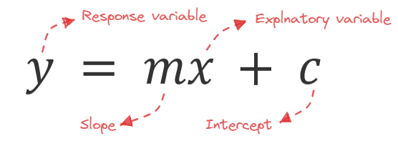

Simple linear regression formula (Image by author)

To know the value of the regression equation produced by the model, we must display the intercept and slope values.

# input  
print(f'intercept: {model\_reg.intercept\_}')  
print(f'slope: {model\_reg.coef\_}')  
  
# output  
intercept: [1.91863322]  
slope: [[9.82609393]]

From the intercept and slope values, we can know that the regression equation produced by the model is y = 9.82609393X + 1.91863322. To confirm the results of the slope and intercept values from Scikit-learn, we can also calculate these values using the equation.

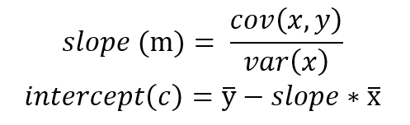

Slope and intercept formula (Image by author)

# calcullate the slope value  
cov\_xy = np.cov(X\_train.flatten(), y\_train.flatten())  
variance\_x = np.var(X\_train, ddof=1)  
slope = cov\_xy[0][1] / variance\_x  
  
# calcullate the intercept value  
intercept = np.mean(y\_train) - slope \* np.mean(X\_train)  
  
print(f"slope: {slope}")  
print(f"intercept: {intercept}")  
print(f"regression formula: y = {slope} X + {intercept}")

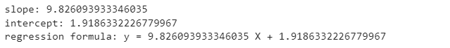

Output

It turns out that the intercept and slope values we calculated are the same as the values from Scikit-learn. Then, we also have to evaluate how good the regression model is. One of the standard metrics for evaluating linear regression models is **R-squared (R²)**[3].

# evaluate the regression model  
from sklearn.metrics import r2\_score  
  
y\_pred = model\_reg.predict(X\_test)  
r\_squared = r2\_score(y\_test, y\_pred)  
print(f'R-squared: {r\_squared}')  
  
# ouput  
R-squared: 0.9230325919412203

The R² value of 0.9230325919412203 indicates that the regression model we have built is quite good. The R² value is in the range of 0 to 1, the accuracy of the regression model is getting better if the R² value is close to 1 [4]. To ensure the R² value generated by Scikit-learn, we can calculate it using the R² formula.

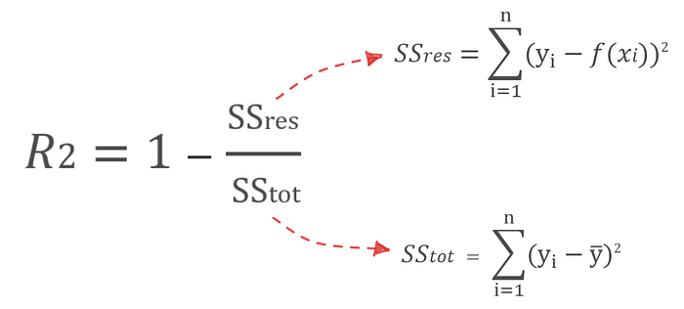

R-squared formula (Image by author)

# calcullate the r-aquared value  
ss\_res = sum([(y\_i - model\_reg.predict(x\_i.reshape(-1, 1))[0])\*\*2  
 for x\_i, y\_i in zip(X\_test, y\_test)])  
ss\_tot = sum([(y\_i - np.mean(y\_test))\*\*2 for y\_i in y\_test])  
r\_squared = 1 - (ss\_res / ss\_tot)  
  
print(f'R-squared: {ss\_res} / {ss\_tot} = {r\_squared}')  
  
# output  
R-squared: [250.45194582] / [3254.] = [0.92303259]

Our results show the same R² value as the calculation from Scikit-learn. We can also use other evaluation metrics such as MAE, MSE, and MAPE to check how well our regression model is.

# Conclusion

Simple linear regression is the **most fundamental concept** of machine learning. It works by **randomly initiating a line**, **fitting the line** to each data point, and **obtaining a line** that is as close as possible to the entire data point. Besides being used to determine the **correlation** between data, simple linear regression can also be used to **make predictions**. A commonly used metric to evaluate how good a linear regression model is is **R-squared (R²)**.